Technology and Society: Is Our Reliance on Electronics a Problem?

It seems to be on everyone’s mind. Article after article, thinkpiece after thinkpiece, all with the same, basic argument: technology is affecting our lives for the worse. Often, it’s small things: we’re more impatient now. We don’t know how to do things on our own. We don’t bother to remember things since we can just Google them. We don’t know where things are anymore, because we just look up directions every time we need to go somewhere.

Some also think it’s affecting our physical health. The dangers of what has been called a “sedentary lifestyle” are well and frequently studied. A new term, “phone separation anxiety,” purports to describe a new type of nervous tic. This crippling disability has inspired much pontification and even a purported treatment, which, perhaps like the syndrome itself, is questionably serious.

Are we reliant on technology? Obviously. Technology plays a larger part in our lives than ever before, and it shows no signs of slowing its relentless penetration of all aspects of our lives. We truly live in a science fiction world. But it’s a natural human tendency to fear and resist change.

Resistance to change is a consistent and recurring feature in human philosophical writing. It’s omnipresent in folk wisdom. ”Better the devil you know than the devil you don’t,” they say, “out of the frying pan and into the fire,” they continue. It seems that there’s a tendency toward conservatism in human thought. Regardless of the state of the known, the unknown is intrinsically more mysterious and therefore threatening.

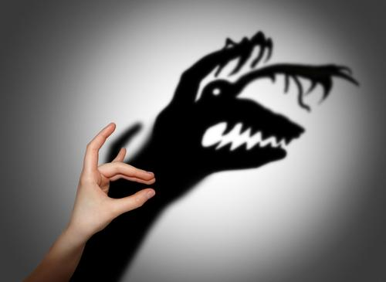

In the early part of the last century, radio was gaining steam and prominence in the national and international consciousness. And with it, perhaps unsurprisingly, came fear! The September 1936 issue of Gramophone Magazine worried that “developed the habit of dividing attention between the humdrum preparation of their school assignments and the compelling excitement of the loudspeaker.” Sound familiar? Let’s check Mashable in 2012: “ 64% of teachers (from middle and high schools) say today’s digital technologies ‘do more to distract students than to help them academically.’” There’s a clear similarity.

It’s also a human tendency to believe that there’s something wrong with young people. The endless hemming and hawing over the supposed problem of the millennial generation strikes one generation as deeply important, and another as utter nonsense. The 1960s brought us the term “generation gap” to describe the rift between young people and their parents, but, as today evidences, perhaps this friction is simply the norm.

When viewed in the context of these common logical fallacies, the issues of our alleged overdependence on technology take on a slightly different hue. For every article that compares technology dependence to drug addiction or an eating disorder, there are ten about how technology can boost your efficiency.

Invariably, the articles asserting our moral decay and decrying the deplorable state of our youngest generation strongly conform to these seemingly intrinsic human biases. Despite the corrupting influence of radio in the classroom, the children of 1936 grew up to be called “the Greatest Generation.” It may be that all this fear and worry is doing more harm than the thing we’re worrying about. Fittingly, we can turn to the wisdom of that president of the greatest generation, FDR: we have nothing to fear but fear itself.
______________________________________________________________________________
Nick Rojas is a business consultant and writer who lives in Los Angeles and Chicago. He has consulted small and medium-sized enterprises for over twenty years. You can follow him on Twitter @NickARojas.

